MISSING PERSON!
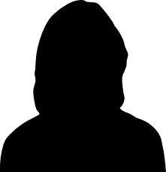
(delete silhouette and insert photo of your loved one)

NAME OF LOVED ONE
INSERT PERSONAL INFO HERE
Please bring our loved one home safely!

NAME OF LOVED ONE has been missing since DATE. SHE/HE was last seen PLACE/LOCATION in CITY/TOWN on DATE at approximately TIME. SHE/HE is RACE/GENDER, about HEIGHT tall and approximately WEIGHT. SHE/HE has LENGTH/COLOR hair. SHE/HE has COLOUR eyes and has SCAR/PIERCING/DISTINGUISHING MARK. SHE/HE was last seen wearing DESCRIPTION OF CLOTHES/SHOES/JEWELRY.

If you have any information or have seen NAME OF PERSON please contact Winnipeg Police Missing Persons at 986-6250. (OR INSERT LOCAL LAW ENFORCEMENT INFO)

(Note – visit www.kanikanichihk.ca for a template of this poster or call 953-5820 for assistance)

