Phone: 204-953-5820
Fax: 204-953-5824
455 McDermot Ave
Winnipeg, MB • R2L 0B5
REFERRAL FORM
Referring Source/Agency: | ________________________________________________________
Your Name & Job Title: | ________________________________________________________
Email Address: | ________________________________________________________
Telephone: | ________________________________________________________
Date Referred: | ________________________________________________________
Family Name of Referral:
______________________________________________________________________________
Home or Cellphone: | ________________________________________________________
Email: | ________________________________________________________
Address: | ________________________________________________________
Reason for referral:
Please provide as much information as possible about concerns addressed to date:
______________________________________________________________________________________________________________________________________________________________________________________________________________________________________________________________________________________________________________________________________________________________________________________________________________________________________________________________________________________________________________________________________________________________________________________________
__________________________________________________________________________________

Authorization for Confirmation of Receipt of Referral:
Confidentiality guidelines require a signed Release of Information form in order to confirm that this referral has been received. This means that Medicine Bear Counselling, Support & Elder Services can only provide a confirmation that this referral has been received to the referring source. The specific content of the counselling sessions will not be shared with the referring source.
Signature of the Individual Referred | _______________________________________________
Signature of the Referral Source | _______________________________________________
** We will contact the family upon receipt of referral **

Chii miigwech for your referral

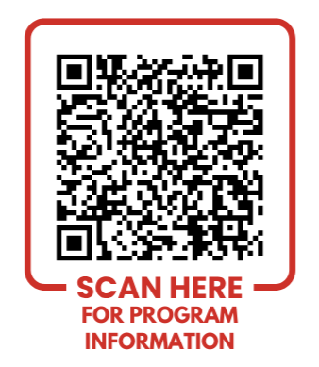
For more information please contact:
medicinebear@kanikanichihk.ca
www.kanikanichihk.ca
204-953-5820

